**Neuro-Style & Recognition: Imagine & learn with Neural Network**

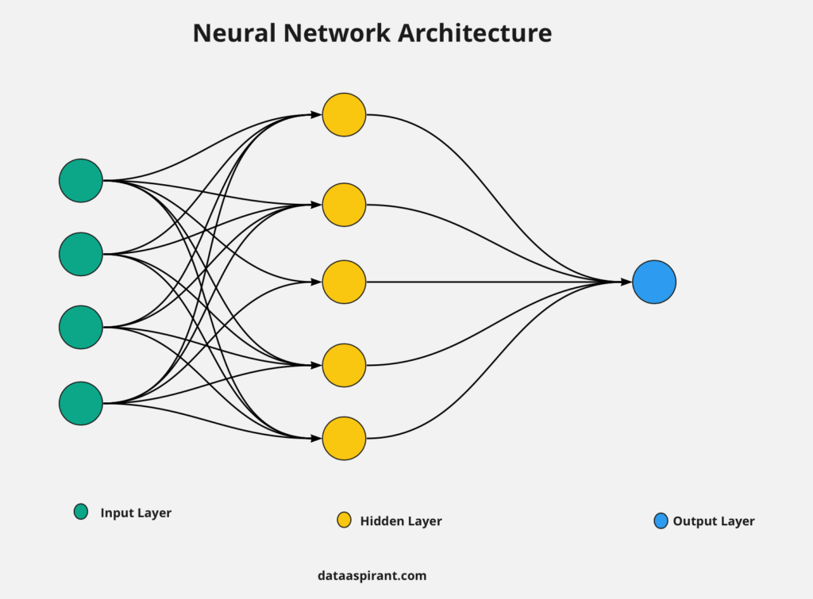

**Abstract:**

This paper presents the development and application of two key projects: Neuro-Style Transfer and Digit Recognition. Neuro-Style Transfer utilizes neural style transfer with the VGG-19 network, integrated with a user-friendly interface (UI) built using the Tkinter library. This tool enables creators to visualize and apply various painting styles to any scenario, enhancing creativity. Additionally, the Digit Recognition project leverages the MNIST dataset to recognize handwritten digits from 0 to 9. Designed for ease of use by children aged 2.5 and above, it features an interactive canvas for drawing digits and educational elements to facilitate learning. Both projects emphasize simplicity and accessibility, making advanced neural network techniques available to a broad audience.

**Introduction:**

The integration of neural networks into creative and educational tools has opened new avenues for enhancing user experiences. This paper explores two such applications: Neuro-Style Transfer and Digit Recognition. Neuro-Style Transfer employs the VGG-19 neural network to apply artistic styles to images, while Digit Recognition uses the MNIST dataset to identify handwritten digits. Both projects are designed with user-friendly interfaces to ensure accessibility and ease of use.

**Discussion:**

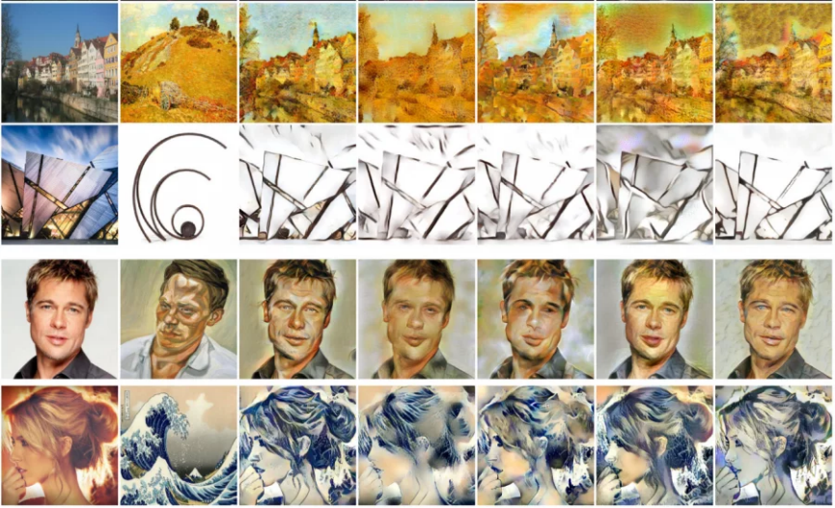

**Neuro-Style Transfer**

**Overview**

* Neural style transfer is a technique that applies the style of one image to the content of another using deep neural networks.
* The VGG-19 network, known for its efficacy in image classification tasks, is utilized to achieve this transfer with minimal parameters, ensuring efficiency.

**Methodology**

* The neural style transfer algorithm involves optimizing an image to simultaneously match the content of one image and the style of another.
* Key components include content and style representations extracted from different layers of the VGG-19 network.
* The optimization process aims to minimize the difference between the content and style features.

**User Interface**

* The project incorporates a UI built with the Tkinter library, making it accessible to users with minimal technical knowledge.
* Users can upload images, select style images, and visualize the output in real-time.
* This UI allows use of neural style transfer to experiment with artistic styles easily.

**Applications**

* This tool is beneficial for artists, designers, and educators, providing a novel way to enhance visual creativity.
* By enabling users to apply diverse artistic styles to their images, it broadens the scope of creative expression.

**Digit Recognition**

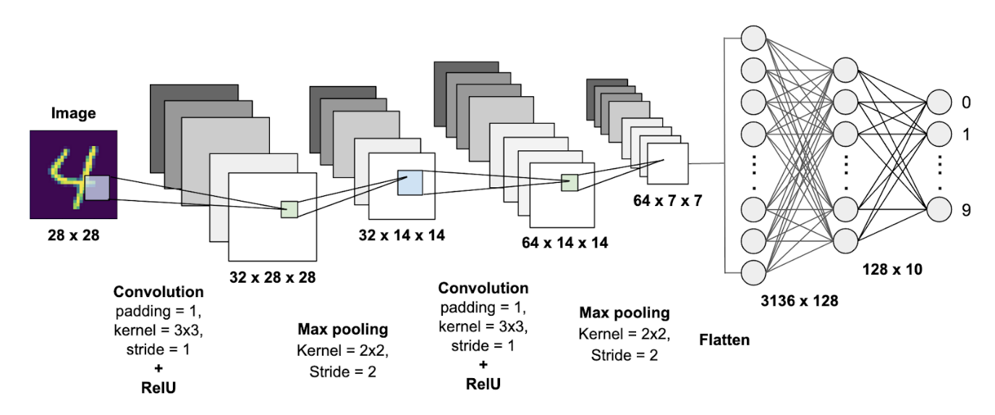

**Overview**

* Digit recognition involves training a neural network to identify handwritten digits from the MNIST dataset.
* The MNIST dataset comprises 60,000 training images and 10,000 testing images of digits ranging from 0 to 9.

**Methodology**

* The project employs a convolutional neural network (CNN) to recognize and classify digits.
* The CNN architecture includes multiple layers such as convolutional layers, pooling layers, and fully connected layers, optimized for digit recognition.

**User Interface**

* An interactive UI made using Gradio allows children to draw digits on a canvas and receive real-time recognition feedback.
* The UI is designed to be intuitive and engaging for young children, with features that display fun facts about the recognized digit.
* This educational tool combines learning with play, making it suitable for children aged 2.5 and above.

**Applications**

* The digit recognition tool serves as an educational aid for parents and teachers, helping children learn numbers in an interactive manner.
* It can be used in educational settings to make learning digits more engaging and effective.

**Literature Survey**

This literature review aims to provide a comprehensive overview of the research landscape surrounding neural style transfer and digit recognition, exploring the evolution of these technologies, the integration of advanced methodologies such as convolutional neural networks (CNNs), the challenges faced, and the future directions of research and development in these fields.

**Neural Style Transfer**

Neural style transfer is a technique that combines the content of one image with the style of another using deep learning algorithms. The pioneering work by **Gatys, Ecker, and Bethge (2016)** introduced the concept of neural style transfer using CNNs, specifically the VGG-19 network. This method involves optimizing an image to match the content representation from one image and the style representation from another. The effectiveness of this approach in generating aesthetically pleasing images has been widely acknowledged in subsequent research (Gatys et al., 2016).

**Digit Recognition**

Digit recognition, particularly using the MNIST dataset, is a well-established task in the field of machine learning. The MNIST dataset, introduced by **LeCun et al. (1998)**, comprises handwritten digits from 0 to 9 and has become a benchmark for evaluating the performance of various classification algorithms.

**Integration with User Interfaces & Educational Applications**

* + The integration of NST with user-friendly interfaces has been a significant development. The use of libraries such as **Tkinter** and **Gradio** to create accessible GUIs allows users with minimal technical expertise to apply artistic styles to images. This has made neural style transfer tools widely available to artists, designers, and educators, enhancing creative expression.
  + The development of interactive UIs for digit recognition has expanded its application in educational contexts. Tools that allow children to draw digits on a canvas and receive real-time feedback provide an engaging way for young learners to practice and learn numbers. Additional features, such as displaying fun facts about the recognized digit, to make learning more enjoyable.

**2.1: Methodology**

The methodology for developing the Neuro-Style Transfer and Digit Recognition projects involves several key steps, including data preparation, model implementation, and user interface development. This section outlines the detailed process for each component.

**Neuro-Style Transfer**

**Importing Libraries**

* + Essential Python libraries are imported, including numpy for numerical operations, tensorflow for building and training neural networks, and tkinter for creating the graphical user interface (GUI).

**Model and Data Preparation**

* + The VGG-19 model pre-trained on the ImageNet dataset is used for neural style transfer. This model is particularly effective in capturing high-level features necessary for style and content extraction.

**Style Transfer Algorithm**

* + The content and style representations are extracted from the intermediate layers of the VGG-19 model. Specifically, deeper layers capture the content while shallower layers capture the style.
  + A loss function combining content loss and style loss is defined. Content loss ensures the output image retains the structure of the content image, while style loss ensures the output image mimics the texture and color patterns of the style image.

**User Interface Development**

* + A user-friendly interface is created using the Tkinter library. This interface allows users to upload content and style images, initiate the style transfer process, and visualize the resulting image.
  + The UI includes options for users to adjust parameters such as the number of iterations and the weights assigned to content and style losses, providing flexibility and control over the style transfer process.

**Digit Recognition**

**Importing Libraries**

* + Essential Python libraries are imported, including numpy for numerical operations, tensorflow for building the convolutional neural network (CNN), and tkinter for creating the GUI.

**Dataset Preparation**

* + The MNIST dataset, which contains 60,000 training images and 10,000 testing images of handwritten digits, is used. The dataset is loaded and preprocessed to normalize pixel values to a range of 0 to 1, enhancing the performance of the neural network.

**Model Implementation**

* + A CNN is constructed for digit recognition. The architecture includes multiple convolutional layers for feature extraction, pooling layers for dimensionality reduction, and fully connected layers for classification.
  + The model is compiled with the Adam optimizer and categorical cross-entropy loss function. The training process involves iterating over the dataset to minimize the loss and improve accuracy.

**User Interface Development**

* + An interactive canvas is created using Tkinter, allowing users to draw digits directly. The drawn digits are captured and fed into the trained CNN for recognition.
  + The UI is designed to be intuitive, with features that display the recognized digit and provide educational content such as fun facts about the digit. This makes the tool engaging for young children.

**Features**

The Neuro-Style Transfer and Digit Recognition projects are designed to provide powerful yet user-friendly tools for creative and educational purposes. Below are the key features of each project:

**Neuro-Style Transfer**

* Necessary but useful Neural Style TransferUser-Friendly Interface
* Developed with the Tkinter library, the graphical user interface (GUI) allows users to easily upload content and style images.Real-Time Visualization
* Displays the generated image in real time, allowing users to see the effects of different styles immediately.
* The interface includes tools to save and export the generated images for further use.
* Designed to be used by a wide range of users, from artists and designers to educators and students.
* The intuitive UI ensures that even users with minimal technical knowledge can perform neural style transfers.
* Customizable Parameters

**Digit Recognition**

* Utilizes a convolutional neural network (CNN) trained on the MNIST dataset to accurately recognize handwritten digits from 0 to 9.
* Interactive Drawing Canvas
* Educational Tool designed for children aged 2.5 and above, the application provides an engaging way to learn digits.
* Displays fun facts and educational content about the recognized digits, making learning enjoyable and informative.
* Ease of Use
* The application can be used in educational settings to teach digits in an interactive manner.

**Limitations of Existing Work**

**Existing Systems:**

* Designed for high-end systems, requiring substantial computational resources.
* Typically lack graphical user interfaces (GUIs), making interaction and usability challenging.
* May include numerous features, many of which are not fully utilized by average users.
* Resource-intensive operations often result in longer processing times, especially on average systems.
* Primarily targeted towards researchers or server-based applications, with limited accessibility for general users.
* Usability may be hindered by complex configurations and technical requirements.

**Limitations overcome by this new “Neuro Style & Recognition” project**

**Neuro System:**

* Tailored for average systems, ensuring compatibility and efficient resource utilization.
* Incorporates a user-friendly graphical interface (UI), enhancing accessibility and ease of interaction.
* Focuses on including only essential features, optimizing usability and streamlining functionality.
* Prioritizes time efficiency, enabling swift execution of tasks even on standard hardware configurations.
* Designed to be user-centric, accessible to individuals with varying technical backgrounds and requirements.

**Results:**

Neuro-Style Transfer: The tool successfully applies various artistic styles to images with high quality, demonstrating the effectiveness of the VGG-19 network in style transfer tasks. This version simplifies some aspects of the original script, incorporates a few new features, and removes others.

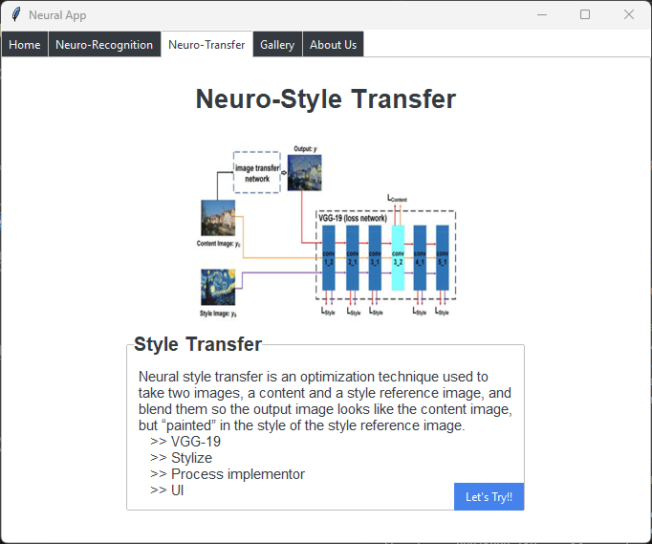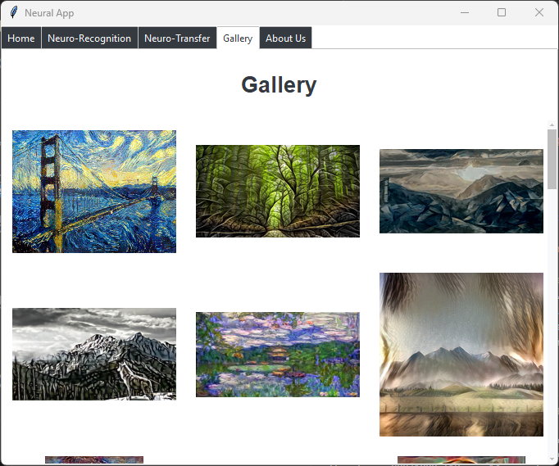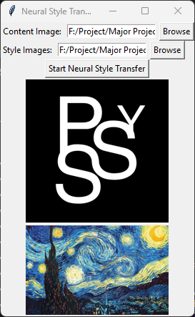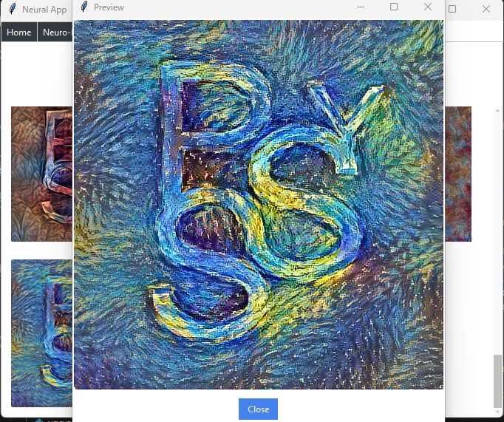

Digit Recognition: The CNN achieves high accuracy in recognizing handwritten digits, providing a reliable educational tool for young children.

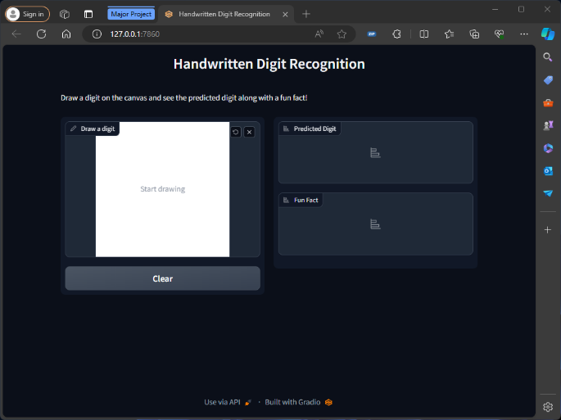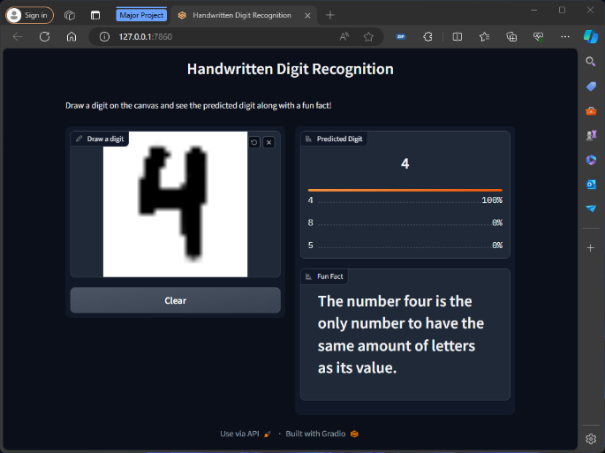

**Conclusion:**

This paper presents two user-friendly applications of neural networks: Neuro-Style Transfer and Digit Recognition. Both projects highlight the potential of integrating advanced neural network techniques with simple UIs to make them accessible to a wider audience. By focusing on ease of use and educational value, these tools can significantly enhance creativity and learning experiences for users of all ages.

**Future Work:**

Expanding the range of artistic styles available in the Neuro-Style Transfer tool.

Incorporating more advanced neural network architectures to improve the accuracy and efficiency of digit recognition.

Developing additional educational features to further engage young learners.

**References:**

*"A Neural Algorithm of Artistic Style" by Leon Gatys et al., originally released to ArXiv 2015*

*“Understanding VGG19” - by various websites (researchgate.net ; arxiv.org ; iq.opengenus.org)*

*Github - anishathalye/neural-style*

*Tensorflow - https://www.tensorflow.org/tutorials/generative/style_transfer*

*https://www.tensorflow.org/datasets*

*TTkbootstrap - https://ttkbootstrap.readthedocs.io/en/latest/styleguide/*